**Mental Health Data Analysis Insights**

Welcome to the repository showcasing insights derived from a comprehensive mental health dataset. In this README.md, I'll provide an overview of the key analysis topics explored using Tableau Public and share the links to the visualizations for further exploration.

**Analysis Topics:**

**1. Growing Stress vs Gender Percentage**

Exploring the distribution of growing stress levels among different genders to understand any potential trends or disparities.

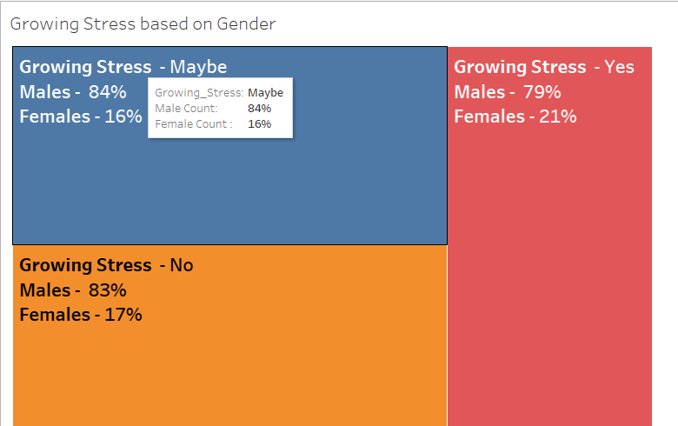

**2. Treatment Required vs Occupation**

Investigating the correlation between occupational roles and the likelihood of requiring mental health treatment.

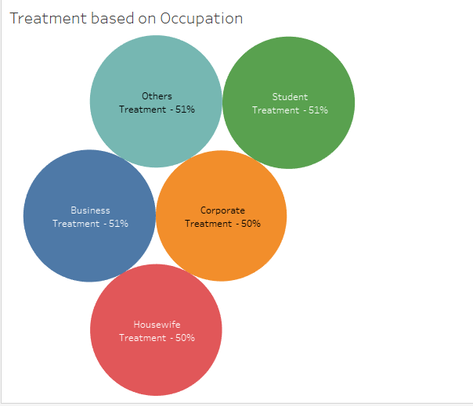

**3. Treatment Required vs Days Indoors**

Analyzing the impact of indoor activities and time spent indoors on the necessity of mental health treatment.

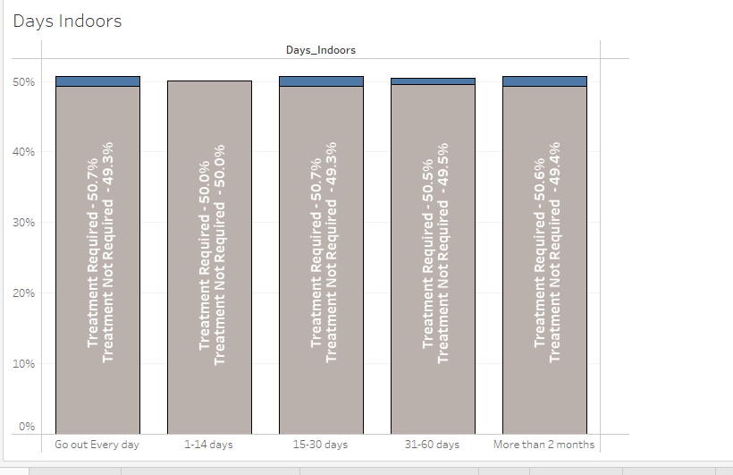

**4. Treatment Required Based on Social Weakness**

Examining how social weaknesses or vulnerabilities contribute to the need for mental health treatment.

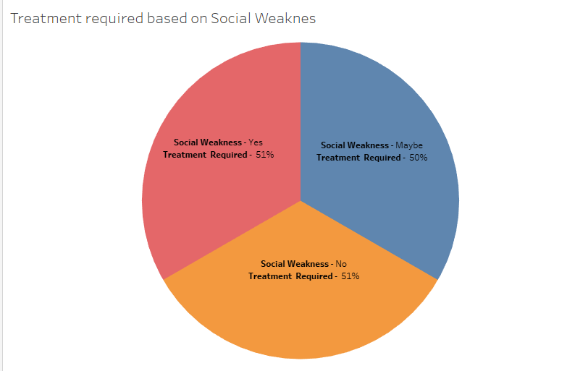

**5. Mental Health vs Family History**

Understanding the relationship between an individual's mental health status and their family history of mental health issues.

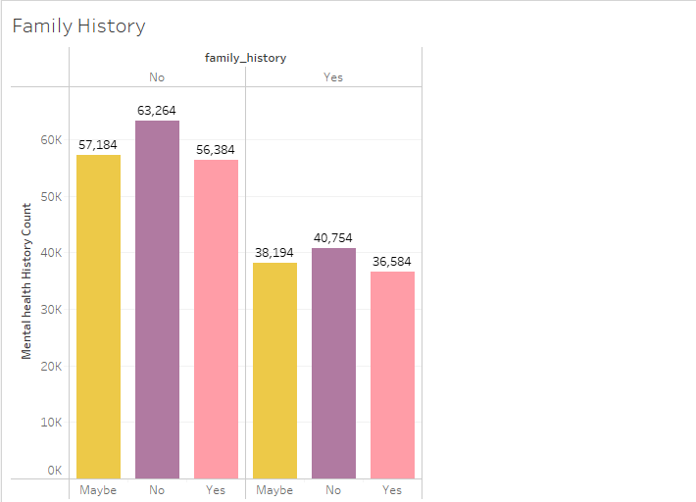

**6. Family History vs Treatment Required**

Assessing the influence of family history on the likelihood of requiring mental health treatment.

https://public.tableau.com/app/profile/md.asif.nawaz/viz/MentalHealthDataAnalysis_17131637003160/TreatmentbasedonFamilyHistory?publish=yes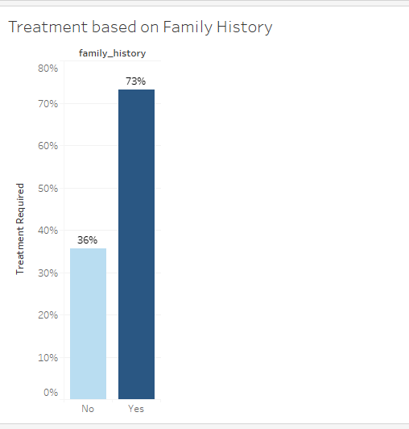

**Visualization Links:**

1. [Growing Stress vs Gender Percentage](https://public.tableau.com/views/MentalHealthDataAnalysis_17131637003160/GrowingStress?:language=en-GB&publish=yes&:sid=&:display_count=n&:origin=viz_share_link)
2. [Treatment Required vs Occupation](https://public.tableau.com/views/MentalHealthDataAnalysis_17131637003160/Occupations?:language=en-GB&publish=yes&:sid=&:display_count=n&:origin=viz_share_link)
3. [Treatment Required vs Days Indoors](https://public.tableau.com/views/MentalHealthDataAnalysis_17131637003160/DaysIndoors?:language=en-GB&publish=yes&:sid=&:display_count=n&:origin=viz_share_link)
4. [Treatment Required Based on Social Weakness](https://public.tableau.com/views/MentalHealthDataAnalysis_17131637003160/TreatmentrequiredbasedonSocialWeaknes?:language=en-GB&publish=yes&:sid=&:display_count=n&:origin=viz_share_link)
5. [Mental Health vs Family History](https://public.tableau.com/views/MentalHealthDataAnalysis_17131637003160/TreatmentbasedonFamilyHistory?:language=en-GB&publish=yes&:sid=&:display_count=n&:origin=viz_share_link)
6. [Family History vs Treatment Required](https://public.tableau.com/views/MentalHealthDataAnalysis_17131637003160/TreatmentbasedonFamilyHistory?:language=en-GB&publish=yes&:sid=&:display_count=n&:origin=viz_share_link)

Feel free to explore each visualization to gain deeper insights into the data and its implications for mental health awareness and support.